In our Simulink simulation, we have 3-phase rectifier, Buck Converter and shunt resistor in order to take feedback, however we are using PI block in order to implement control loop. In real world, we need controllers (analog/digital) to implement this loop, we need gate driver’s in order to drive MOSFETs and we need isolations in order to keep logical operations in safe zone.

In this project, we will control our battery current by using a PIC microcontroller. However, these digital controllers are very sensitive and easly disturbed by a noise, so we need to isolate our topology’s analog and digital parts, with a current sensing op-amp. Moreover, we need to take the generated PWM from PIC to our analog circuit side, so we need a digital isolator. Moreover, this coming signal will not be able to drive the MOSFET gates due to low power and voltage, so we need a gate driver with our low-side and high-side MOSFET’s in Buck Converter and this driver must have a bootstrap circuit in order to drive high-side MOSFET. Lastly, we need to feed supplies of these discussed IC’s, so we need to convert battery’s 24V to desired levels, where we will select these desired levels in following sections.

**Isolation Op-Amp**

Like in every component, we need a cheap and feasible isolation op-amp in order to isolate our Shunt Voltage from the logic side of the circuit. For this purpose, a two channel op-amp was enough for us, and while doing our research, we have found SI8920BC (Silicon Labs) model current sensing isolation op-amp. This model is one of the most cheap isolation op-amps in Mouser and has specifications that we are needed at all. SI8920 has a supply range 3.0V to 5.5V, it’s differential inputs are capable up to +/-200mV, it’s default gain is 8.1 and in datasheet, it’s typical usage is for current sensing, which is our purpose.

We want all of the IC’s with 3.3V supply in our circuit, where SI8920BC is suitable, our shunt voltage will be around 20mV (with 0.01 ohm shunt resistor and the current is around 2A), and with gain, it’s output will be around 160mV, where this voltage is enough for ADC readings. As a consequence of the features that we count above, we have chosen the SI8920BC for our shunt voltage isolation.

**Link:** [**https://www.mouser.com.tr/ProductDetail/Silicon-Labs/SI8920BC-IP/?qs=bB7QTEcmLuN2VIVidYwh9w==**](https://www.mouser.com.tr/ProductDetail/Silicon-Labs/SI8920BC-IP/?qs=bB7QTEcmLuN2VIVidYwh9w==)

**Price(Si8920BCx1):** 2.48 Euro

**Digital Isolator**

In our Buck Converter, we have two MOSFETs which are standing for high side and for low side. In order to use these MOSFETs as switches, we need PWMs, which are generated from the controller which will be discussed below. As we mentioned, our controller side will be isolated, so we need a digital isolator which will carry logic side generated PWMs into our analog side.

We will have two PWMs, and for them a two channel digital isolater will be enough for us. As we mentioned before, we are planning the supplies of ICs as 3.3V, so we need to select our digital isolator in that way. When we filtered the components with desired properties above, we have found SI8620AB (Silicon Labs). This digital isolator is a unidirectional, two-channel, 2.5V-5.5V supply range and one of the most cheapest solutions. As a consequence of discussed properties, we are selected SI8620AB for our digital isolator.

**Link:** [**https://www.mouser.com.tr/ProductDetail/Silicon-Labs/SI8620AB-B-ISR/?qs=j6MGy4L9yX20sFXZc1kgqQ%3D%3D**](https://www.mouser.com.tr/ProductDetail/Silicon-Labs/SI8620AB-B-ISR/?qs=j6MGy4L9yX20sFXZc1kgqQ%3D%3D)

**Price:** 0.85 Euro

**Digital Controller**

In our topology, we are selected to control our battery current with a digital controller in order to have an adjustable, reliable and easy setup circuit. By using a digital controller, we are getting away from complicated and fixed burden of analog controllers. If we use an analog controller, we can not change control parameters P and I easily when there is an application error of control loop. Moreover, with digital controller, our circuit will be able to charge battery for different currents, which will make our design more desirable.

For digital controller, we wanted to use Microchip’s PIC controllers, due to their easy and useful configuration. When we looked into PIC and dsPIC microcontrollers, we have seen that dsPICs are more complicated, however we only need a Analog-to-Digital Converter and PWM generator, so we decided to move into PIC controllers. When we make a research on Microchip website for ADC and PWM modules with cheap solutions, we are ended up on PIC16F16 series controllers, because these series are specialized for PID control and math operaations. While looking the cheapest solution, we have found PIC16F1613 module, which is a fourteen-pin small controller, however there is not a seperated PWM module in this PIC16F1613, PWM module is connected to Compare-Capture Module, which may be problematic while initializing PWM in code, so we moved into PIC16F1614. This module has 10-bit ADC module connfigurable for all analog pins and a CWG (complementary waveform generator) module which is suitable for driving of a half-bridge, again this module is configurable for all digital pins.

To conclude, with 3.3V supply, 10-bit ADC, CWG, specialized for PID control and cheap price features, we are decided to use PIC16F1614 as digital controller in our circuit.

**Link:** [**https://www.microchip.com/wwwproducts/en/PIC16F1614**](https://www.microchip.com/wwwproducts/en/PIC16F1614)

**Price:** 0.96 Dolar

**Gate Driver**

In our Buck Converter, we have two MOSFETs for high side and low side which will be driven complementary, with PWMs generated from our digital controller, however these PWMs are not have enough voltage to drive our MOSFET gates, moreover for high side we need a bootstrap configuration for drive. For this purpose we need a gate driver in our circuit.

From our simulations, we know that our high side MOSFET sees a voltage up to 300V between drain and source, so we need to select a suitable driver. Moreover, in order to prevent short circuit between drain of high side and source of low side we need a proper dead time between complementary PWMs, by considering turn-on and off delay times. When we look the datasheet of our MOSFETs in Buck Converter (FDD5N50NZ), the maximum turn-on delay time is 35ns and the maximum turn-off delay time is 65ns, so at least we need a dead time higher than 100ns.

While doing our research on Mouser, we have ended up with 2 models, which are 2ED2182S06FXUMA1 and BS2103F, with 650V and 600V high voltage purpose, respectively. Both models are suitable for our voltage range and have bootstrap application, however the first model is expensive than second. When we look further, we see that gate current of first one is up to 2.5A and the second one is 130mA. We are using MOSFETs, so we do not need a high gate current, when we examine the datasheet of the first one, we see that it is suitable for IGBT, too, due to high gate current. When we look dead times, first one has 400ns dead time and it is adjustable with R-C circuit, and second one has fixed 160ns dead time.

As we discussed above, a dead time higher than 100ns is suitable for us, and we are driving MOSFETs, we do not need high gate current, for this purpose we have selected 2nd option which is cheaper, BS2103F. This model has supply range between 10V and 18V.

**Link:** [**https://www.mouser.com.tr/ProductDetail/ROHM-Semiconductor/BS2103F-E2/?qs=iaprbs8w3G9rav1d9DTYOA%3D%3D**](https://www.mouser.com.tr/ProductDetail/ROHM-Semiconductor/BS2103F-E2/?qs=iaprbs8w3G9rav1d9DTYOA%3D%3D)

**Price:** 0.84 Euro

**Power Conversion Units**

As we mentioned above, except gate driver, we have selected all of our IC’s with 3.3V, and our gate driver has a supply range between 10V and 18V. We can select supply of gate driver as 12V, so we need to convert 24V battery voltage into 12V and 3.3V separately, and for isolated supplies, we need to convert 3.3V into isolated 3.3V, which means we need three converters which are 24V/12V, 24V/3.3V, 3.3V/Isolated 3.3V.

In following sections, we have decided our conversions with cheapest way with considering IC supply currents.

1. **24V/12V Conversion:**

When we look cheapest solution for 24V/12V conversion, we have ended up with UA7812CKCS, which is a linear voltage regulator with fixed 3.3V 1.5A output for 14.5V-25V input range. This will supply only gate driver, whose supply current is at most 1mA, where our converter is enough. Moreoveri this model is through hole, so we can place it vertically in our circuit for lower space.

**Link:** [**https://www.mouser.com.tr/ProductDetail/Texas-Instruments/UA7812CKCS/?qs=DcvZ7Fltd5zyvhYGYzcR7A%3D%3D**](https://www.mouser.com.tr/ProductDetail/Texas-Instruments/UA7812CKCS/?qs=DcvZ7Fltd5zyvhYGYzcR7A%3D%3D)

**Price:** 0.67 Euro

1. **24V/3.3V Conversion**

While doing our reaseach for 24V/3.3V conversion, we have ended up in two models which are BA033CC0FP and UA78M33CKVURG3, which are LDO and Linear regulators, respectively. A LDO regulator is more power efficient, moreover our LDO regulator is 1A, however our linear regulator is cheaper but has 500mA output. When we look our ICs, we have 2 ICs with 3.3V supply and in the worst case, isolated op-amp draws 4.2mA maximum, for digital isolation that current is 1.2mA. Which means we do not need high currents, so we have selected the second one which is UA78M33CKVURG3, cheaper solution.

**Link:** [**https://www.mouser.com.tr/ProductDetail/Texas-Instruments/UA78M33CKVURG3/?qs=0O%2FZFlpUpJXrDg4gfD1Q2g%3D%3D**](https://www.mouser.com.tr/ProductDetail/Texas-Instruments/UA78M33CKVURG3/?qs=0O%2FZFlpUpJXrDg4gfD1Q2g%3D%3D)

**Price:** 0.49 Euro

1. **3.3V Isolation**

For a non-disturbed operation, we need that isolation, however the isolation is a very expensive event. Due to this fact, we have selected the cheapest solution for 3.3V isolation. While we are doing our research, we have found R1SX-3333R, which gives isolated 3.3V with 303mA output. We have three IC’s with isolated 3.3V supply, and the worst one in worst case draws 4.2mA according to datasheet, so 303mA is enough.

**Link:** [**https://www.mouser.com.tr/ProductDetail/RECOM-Power/R1SX-3333-R/?qs=AQlKX63v8Rsf1yduGKaK6w%3D%3D**](https://www.mouser.com.tr/ProductDetail/RECOM-Power/R1SX-3333-R/?qs=AQlKX63v8Rsf1yduGKaK6w%3D%3D)

**Price:** 2.46 Euro

**Connectors**

We have three terminals in our circuit which are motor phases, battery terminals and in circuit serial programming (ICSP) pins. For motor phases and battery terminals we will use screw connectors, and for ICSP we will use headers.

**Motor Connector Link:** <https://www.mouser.com.tr/ProductDetail/Phoenix-Contact/5452258/?qs=iCzJi%2FIZBF77ZcTXZHmYbQ%3D%3D>

**Battery Connector Link:** <https://www.mouser.com.tr/ProductDetail/CUI-Devices/TB007-508-02BE/?qs=vLWxofP3U2y6PFKAfCqKUQ%3D%3D>

**ICSP Connector Link:** <https://www.mouser.com.tr/ProductDetail/Amphenol-FCI/67997-100HLF/?qs=cpLrBgdhsoH33Mp6xh%2FbyQ%3D%3D>

**Total Price:** 1.87 Euro

**Schematic Design**

After concluding our topology selection, ideal/non-ideal simulation results and component selection part, we moved into schematic design part. In schematic part we have used Altium Designer 20, we have worked hierarchically which have easened our design. Our subparts are rectifier unit, converter unit, isolation unit, logic unit, power unit and connector unit. Overview of hierarchy can be seen in figure 1.

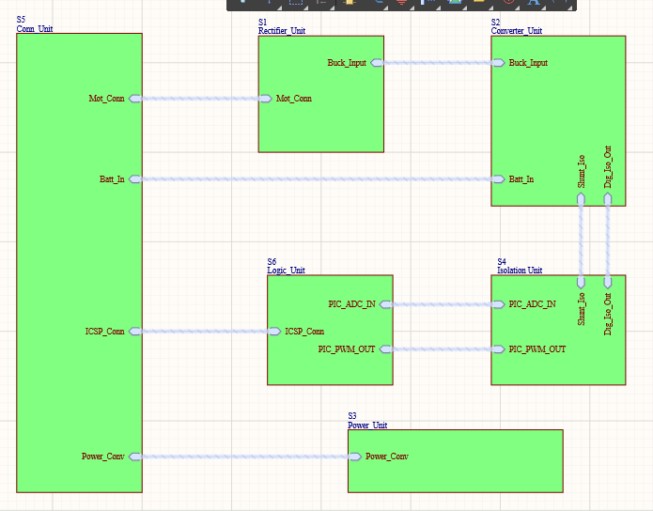

**Figure-1:** Overview of Hierarchical Design

1. **Rectifier Unit**

As seen in figure 2, in our rectifier unit we have our selected diodes and capacitor for three phase diode rectifier, which has the same design with Simulink simulations.

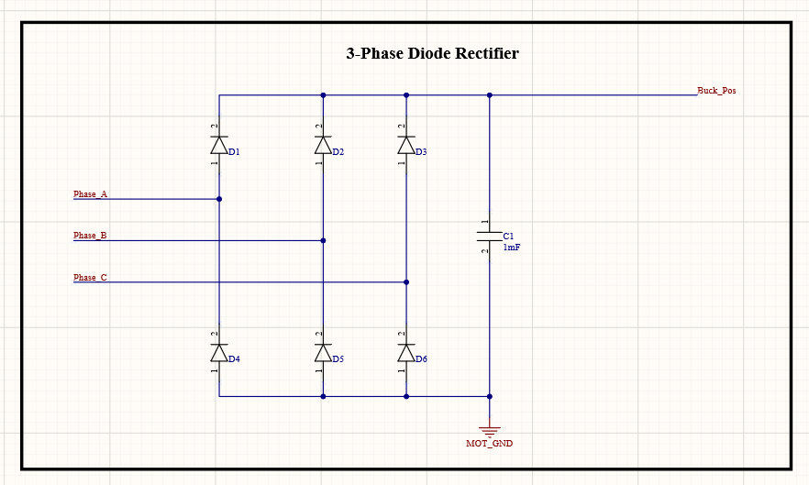

**Figure 2:** Three Phase Full Bridge Diode Rectifier Schematic

1. **Converter Unit**

In converter unit, we have three parts which are buck converter, shunt resistor and gate driver. Buck converter design is same with Simulink simulations, shunt resistor is connected between negative terminal of battery and ground, which can be seen in figure 3.

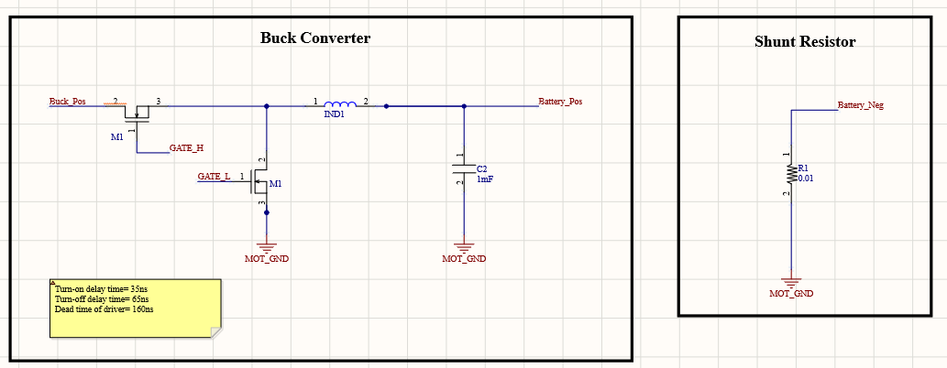

**Figure 3:** Buck Converter and Shunt Resistor Schematic

When we examined the selected gate driver’s datasheet, in recommended connection we are needed a 1uF bootstrap capacitor, and two times of bootstrap capacitor for supply bypass capacitance. Moreover, for bootstrap circuit, we need a diode between supply and positive terminal of bootstrap capacitor. While driving MOSFET gates, small resistances are required for current slew rate, so we added 20 ohms to gate paths. These discussed features of gate driver circuit can be examined in figure 4.

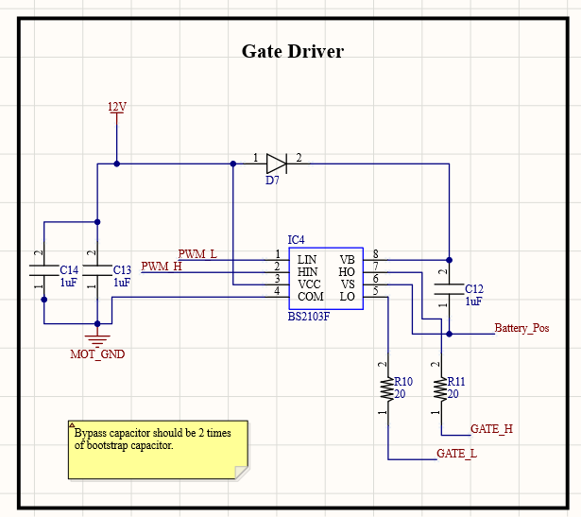

**Figure 4:** Gate Driver Schematic

1. **Isolation Unit**

As we discussed in component selection part, we are needed isolation for digital side of our circuit. In our schematic, isolation unit includes two main parts which are isolating op-amp and digital isolator.

When we examine the datasheet of our selected isolating op-amp, we see that for both supplies we are needed 100nF bypass capacitors, for differential input of our op-amp we are given a recommended filtering R-C circuit constructed with 20 ohm resistors and 10nF capacitor. At the output of isolation, we need again filtering for ADC input, and the cut-off frequency is determined by user. The only information given is resistors should be bigger than 5kohms. We have assumed our PWM frequency as 30kHz and cut-off frequency as 15kHz to prevent isolation from PWM noise, we have assumed the resistors as 5.6kohms, so we have found the filtering capacitor as 1uF. Isolatin op-amp circuit can be examined in figure 5.

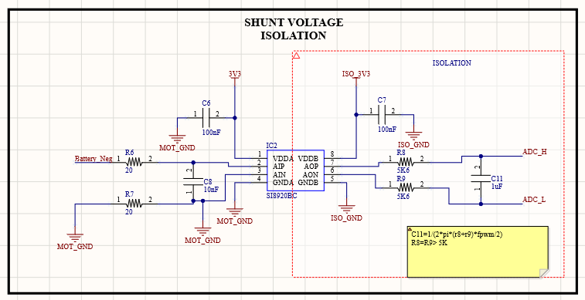

**Figure 5:** Isolating Op-amp Schematic

In our selected digital isolator, we only need bypass capacitors which are recommended in datasheet as 100nF. In figure 6, digital isolator schematic can be seen.

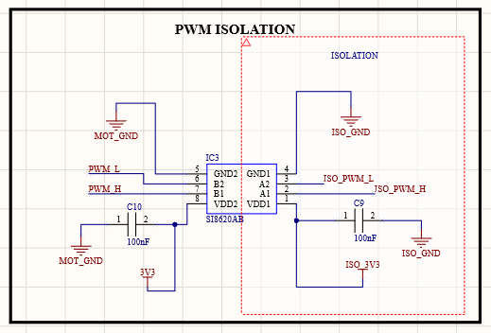

**Figure 6:** Digital Isolation Schematic

1. **Logic Unit**

In logic unit, we have our selected digital controller which is PIC16F1614. In the datasheet of this controller, we need bypass capacitors 10nF and 100nF. In this microcontroller, we have pins for in circuit serial programming which are MCLR, ICSPDAT and ICSPCLK, which are connecting fo PICKIT. In recommended connection, ICSPDAT and ICSPCLK have direct connection, however we are given a recommended connection for MCLR with 10kohms and 4.7kohms resistor and 100nF bypass capacitor. Moreover, in this part of schematic we have ADC inputs and PWM outputs, where PWM outputs have pull-down resistors for safe operation. Schematic of controller can be seen in figure 7.

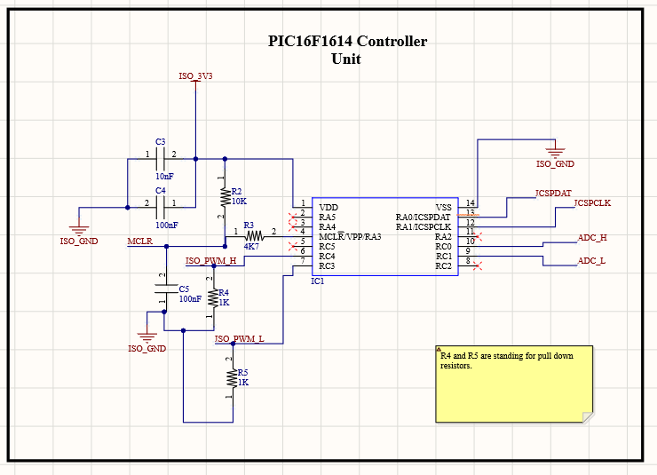

**Figure 7:** Controller Schematic

1. **Power Unit**

In power unit of schematic, we have selected 24V/12V, 24V/3.3V and 3.3V Isolation equipments. In this part, we only have extra bypass capacitors that are recommended in datasheets. In figure 8 24V/12V and 24V/3.3V, and in figure 9 3V isolation schematics can be seen.

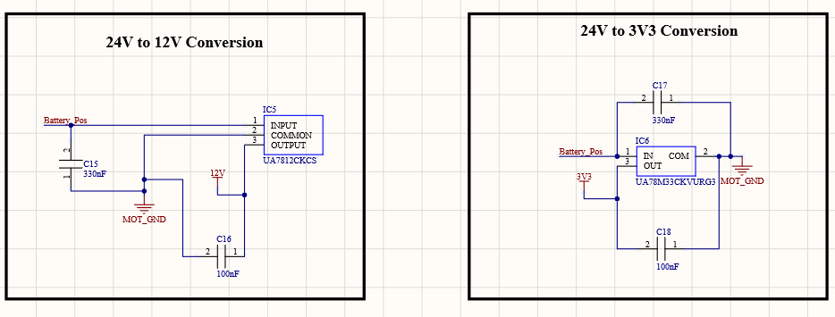

**Figure 8:** 24V/12V and 24V/3.3V Conversion Schematic

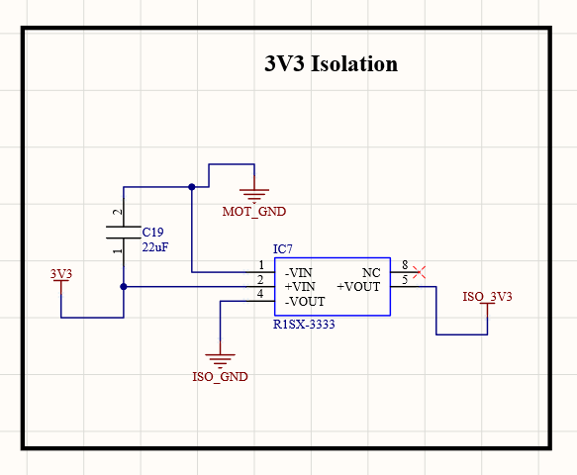

**Figure 9:** 3.3V Isolation Schematic

1. **Connector Unit**

As we discussed before, we will use screw connectors and headers in order to achieve flexibility in connections. Schematic of connectors can be seen in figure 10.

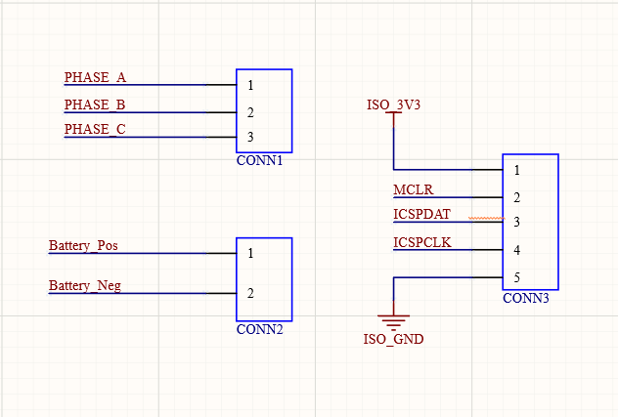

**Figure 10:** Connector Schematic

To sum up the schematic design, we have designed our circuit in detail by investigating and exploring all of the datasheets deeply. We have considered needed bypass capacitors, diodes, pull-down resistors and other equipments. We will carry this detailed work into PCB works to achieve best design.